R_q_n13_sys4x4

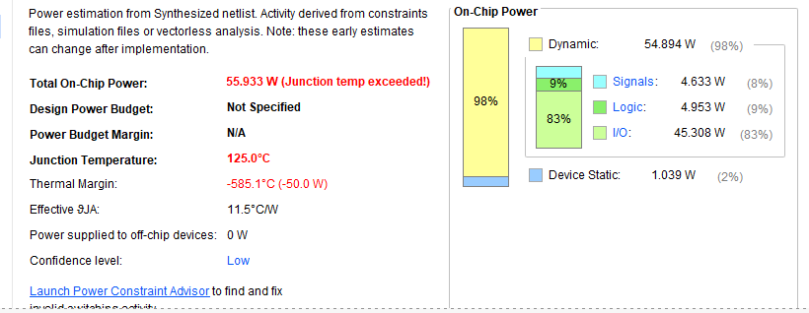

R_q_n13_sys5x5

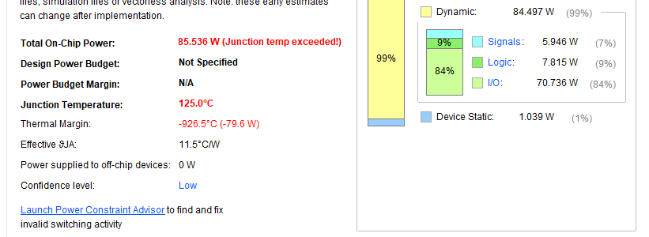

R_q_n13_sys6x6

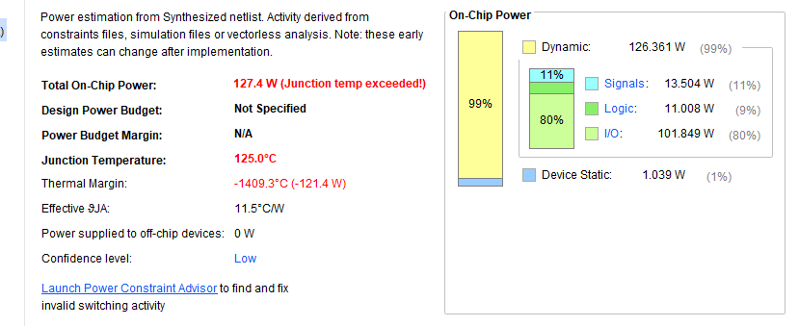

R_q_n29_sys4x4

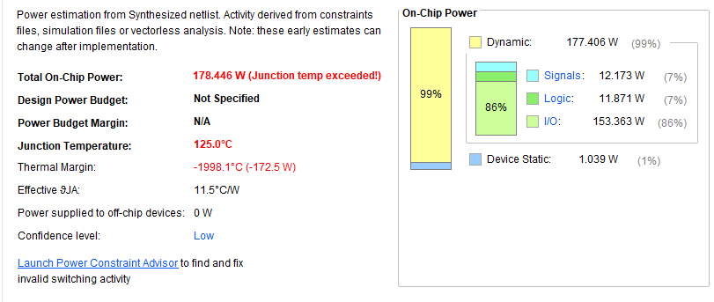

R_q_n29_sys5x5

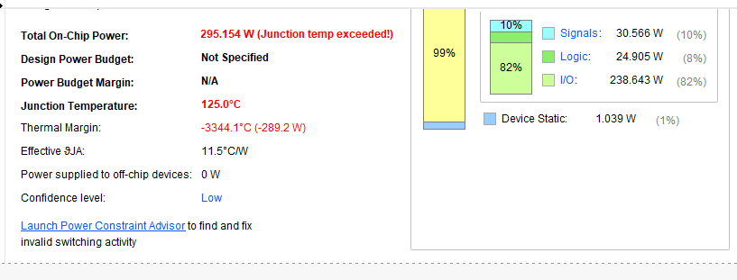

R_q_n29_sys6x6

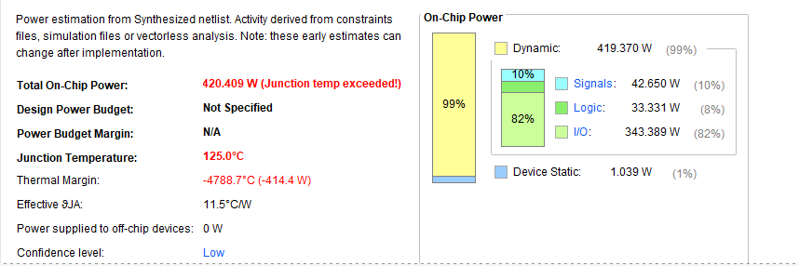

R_q_n37_sys4x4

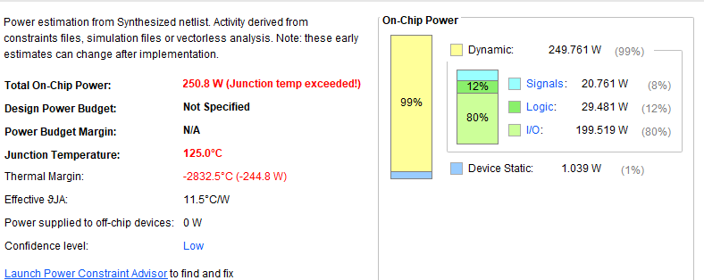

R_q_n37_sys5x5.

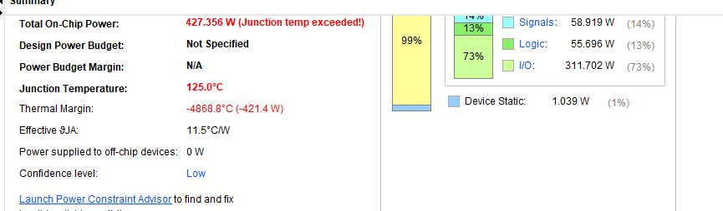

R_q_n37_sys6x6

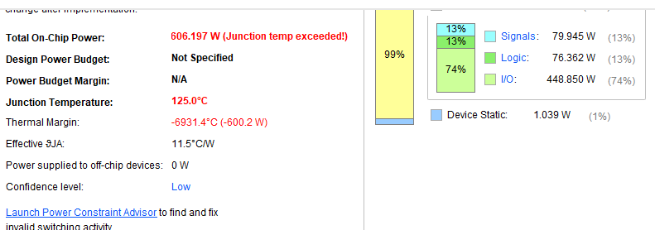

Cg_n13sys4x4

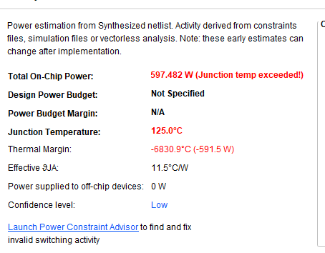

Cg_n13sys5x5

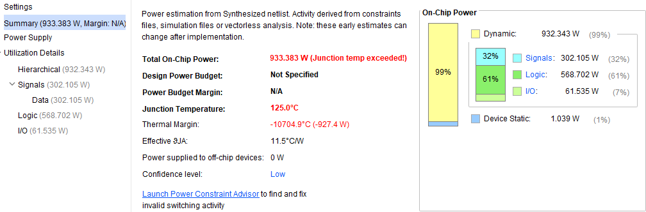

Cg_n13sys6x6

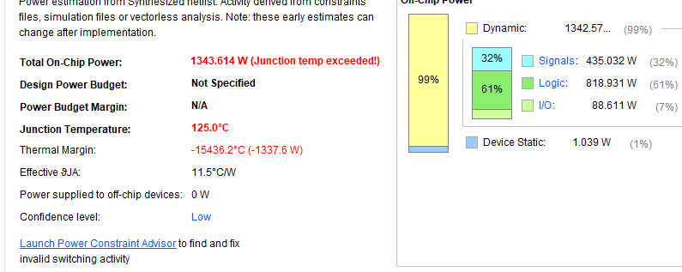

Cg_n29sys4x4

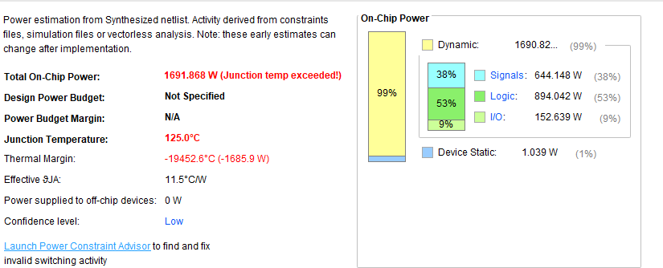

Cg_n29sys5x5

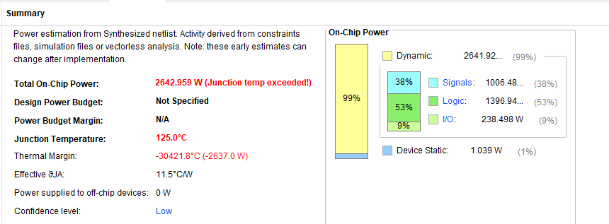

Cg_n29sys6x6

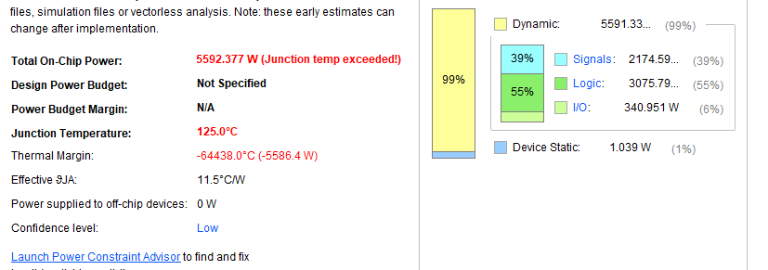

Cg_n37sys4x4

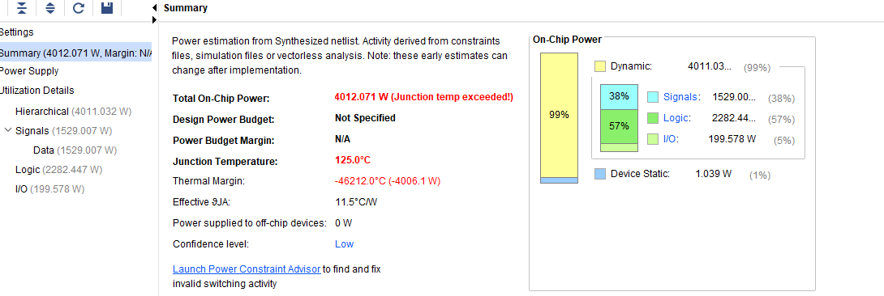

Cg_n37sys5x5

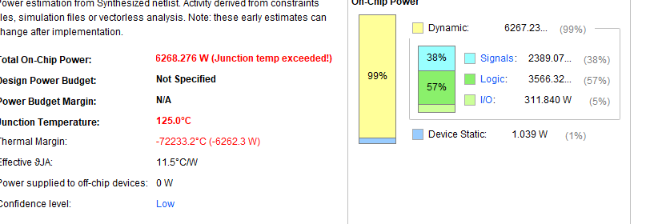

Cg_n37sys6x6

